website propsal
2 MAY 2025

PREPARED FOR: THE LECTURE PREPARED BY: BLESSINGS MUKHININDI ST10518984

WEDE

TABLE OF CONTENT
1.Organisation Overview………………2
2.Website goals and objectives …….2-3
3.Current website analysis……………3
4.Proposed website features…………3-4
5.Desgin and user experience……….4
6.Technical Requirements…………….4
7.Timeline and Milestones…………….4-5
8.Budget…………………………………….5
9.References………………………………5

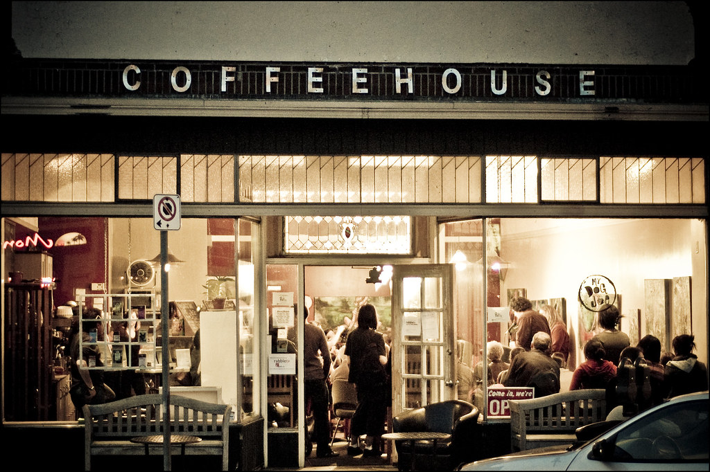
This Photo by Unknown Author is licensed under CC BY-NC

Target Organisation: Bean and Brew Café
1.Organisation Overview
My name is Blessings Mukhinindi, and I recently started a small café called BEAN & BREW CAFÉ in a local suburb in Johannesburg, South Africa. I wanted to create a cozy space where people could enjoy good coffee, snacks, and a friendly atmosphere. The café is just getting started, and the goal is to build a loyal local community of customers.
Mission Statement
To serve a great coffee and simple, tasty food in a welcoming and relaxed environment
Vision Statement
To grow into a café that the local community loves and feels at home in
Target Audience
-Primary: Students, young professionals, and residents who enjoy coffee and casual hangouts
-Secondary: People passing by or looking for takeaway coffee and snacks.
-Demographics: Ages 16-35, community-focused, and value cozy, friendly spaces

2.Website Goals and Objectives

WEBSITE GOALS
Provide Information: Share details about the café, menu, opening hours, and location so potential customers can easily find us.
Attract Customers: Increase interest and awareness in the local community and online visitors.
Enable Online Orders/Bookings: Allow customers to place takeaway orders or reserve tables online for convenience.
Promote the Brand: Build a friendly, recognizable brand that reflects the cozy and welcoming vibe of the café.
WEBSITE OBEJECTIVES
Increase Website Traffic: Create content (like menu highlights and café photos) that encourages people to visit the website regularly.
Generate leads: Collect email addresses or social media follows from visitors to share updates, promotions, and events.
Sell Products /Services Online: Offer online ordering for coffee, snacks, and small bakery items for takeaway or delivery.
Provide Valuable Information: Include clear information about menu items, prices, opening hours, location map, and contact details to make it easy for customers to reach the café.

3. Current Website Analysis
BEAN & BREW CAFÉ is a new business, so there is no existing website now. However the website is in development as part of this project, and it will serve as the primary online presence for the café.
Purpose of the website
The website will allow customers to:
-learn about the café, its menu, and operating hours.
-place orders online or make table reservation.
-contact the café directly or connect via social media.

4.Proposed Website features and Functionality
The BEAN & BREW CAFÉ website will include essential pages and function that allow customers to easily access information, place orders, and engage with the café online.
Home Page
-Features: Welcome message, hero image of the café, quick overview of menu highlights, and café hours
-Functionality: Visitors immediately see what the café offers and can navigate easily to other pages.
About Us Page
-Features: Brief history of the café, mission and vision statements, photos of the café and staff.
-Functionality: Helps build trust and connection with customers by telling the café’s story.
Menu/Product Page
-Features: Detailed menu items with descriptions, prices, and images. Categories, like coffee, snacks, and desserts.
This Photo by Unknown Author is licensed under CC BY-ND
-Functionality: Visitors can view the menu clearly and select items for takeaway or online ordering if available.
Contact Page
-Features: Café location map, phone number, email address, and social media links
-Functionality: Customers can easily reach out for questions, orders, or reservations.

5.Design and User Experience
Colour scheme: Warm, earthly tones like brown, creams, and soft oranges to evoke a coffee shop feel.
Typography: Easy-to-read fonts such as Calibri and Montserrat, with headings slightly bolder for emphasis.
Layout and design: Simple, intuitive layout with clear navigation, hero images, and sections for menu, about, and contact.
User experience consideration: Mobile-friendly design, fast loading pages, easy to find information, and simple ordering reservation forms for convenience.

6.Technical requirements:
The website will be developed using html to demonstrate basic web development principles.
The project will require a domain name such as -www.bean&brew.co.za

7.Timeline and Milestones:
Week1 – Research and planning of the website. Define goals, targets audience, and website requirements.
Week 2- Create the website structure and design the layout (Home, About Us, Menu, Contact pages).
Week3-Develop the website content including text, images, and menu details.
Week4-Test the website to ensure all page’s work properly and are mobile- friendly
Week5-Final review, make improvements, and prepare the website proposal for submission.

8.Budget
Website development-R3,500
Domain Name Registration-R150
Website Maintenance-R800
Web hosting-R1,200
TOTAL ESTIMATED BUDGET = R5,650

9.Reference
Nielsen, J (2020) Designing Web Usability: The practice of Simplicity. 2nd edn. Indianapolis: New Riders
Smith, A (2021) ‘Coffee shop business trends in 2021’, Journal of Food and Beverage Business, 12(3), pp. 45-58.
Coffee Association of South Africa (2023) Coffee Industry Statistics [Online].
Available at: https :// www.coffeebeans.co.za/statistics(Accessed: 13 March 2026).
W3Schools (2026) HTML and CSS Tutorials [Online}. Available at: https://www. Coffeebeans.co.za/statistics (Accessed: 13 March 2026)
Adobe (2025) Adobe XD: Design and Prototype Tools {Onilne}. Available at:https://www.adobe.com/xd (Accessed:13 March 2026
